**SAMPLE T TEST**

**Name : G. NITHISH**

**Reg. no. : 19BCS0012**

**Procedure :**

1. Go to **variable view** and create name as scores with measure as scale.
2. Click on **data view** and fill the scores according to the question.
3. Select “**Analyze”**option from the tool bar above.
4. Click on “**Compare Means”** then “**One Sample T Test”**.

**Variable View**



**Data View**

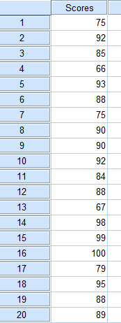

**Output T Test Table**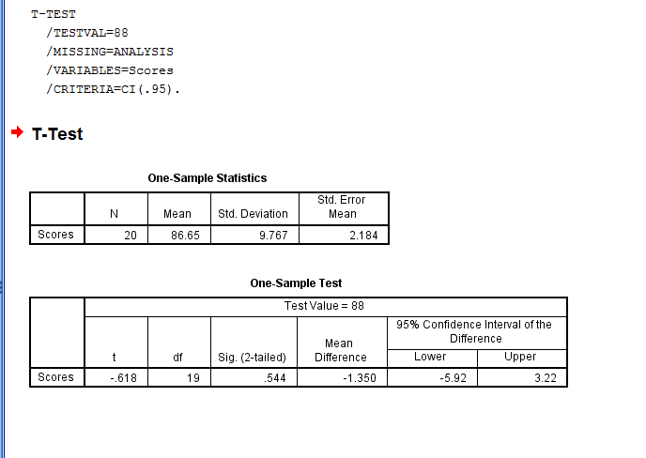

**Questions:**

1. What was t value? : -0.618(calculated value)
2. What was test value? : 88
3. What is the mean from the table? : 86.65
4. What is the value of samle size from the table? : 20
5. Critical t from the t table : 19(degree of freedom**“df”**)
6. Significance level : 5%
7. Confidence level : 95%
8. Table value from the t table : 2.09(table value)

**Conclusion:**

* Calculated Value : -0.618
* Table Value : 2.09

**Since, calculated value < table value**

**Therefore, H0 =μ = 88**

Q 2: variable view

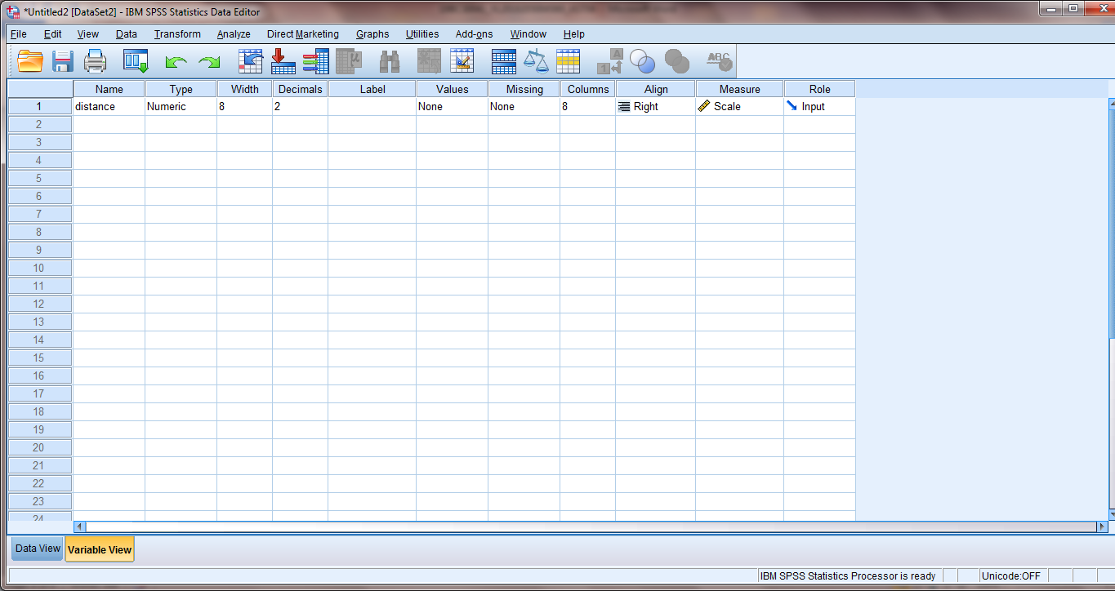

Data view:

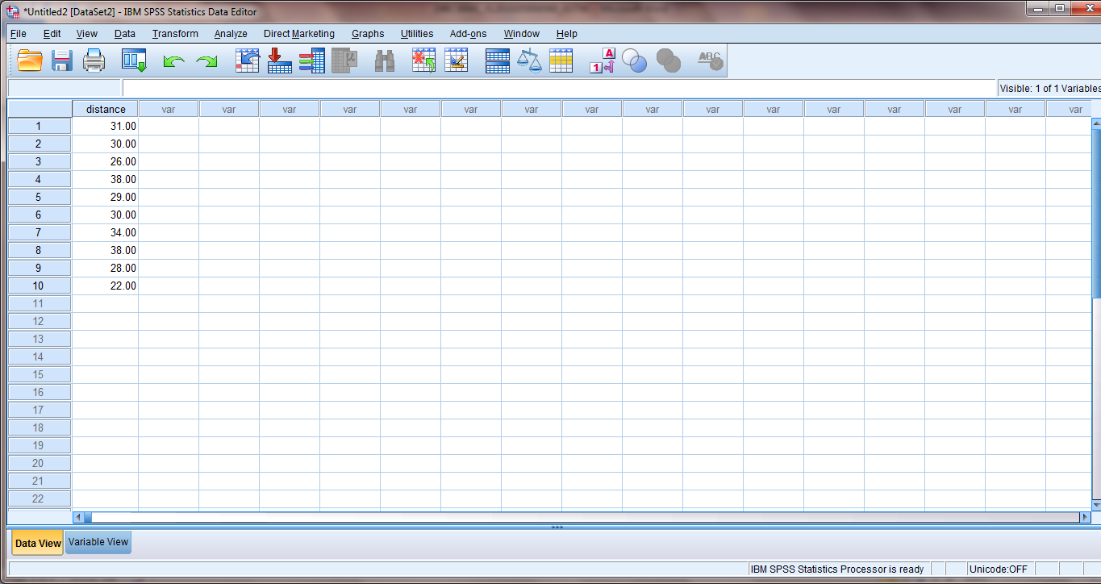

Output:

